APPENDIX A:
PHOTOGRAPHS TAKEN DURING JIV AT 10’’ CLOUGH CREEK/TEBIDABA PIPELINE AT AZAGBENE IN EKEREMOR LOCAL GOVERNMENT AREA OF BAYELSA STATE.

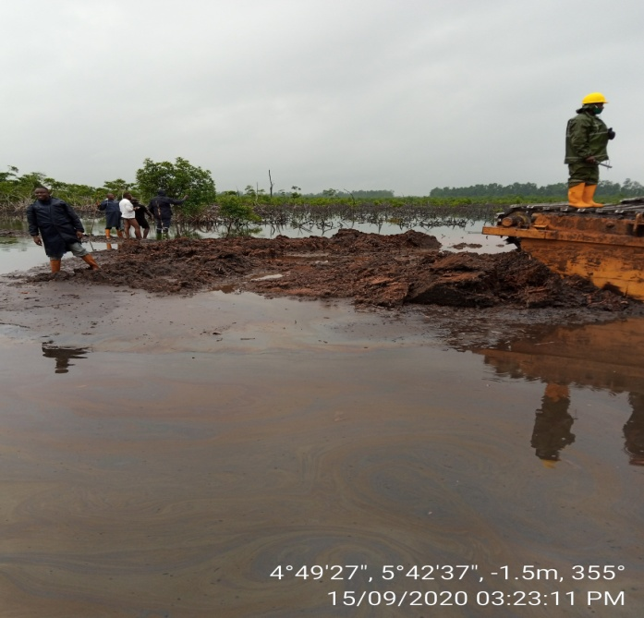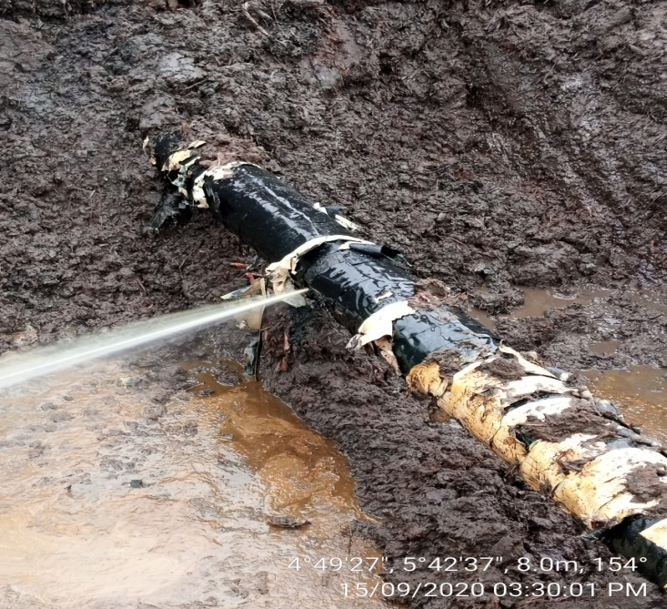
PIPELINE WRAP NOT TEMPERED
BEFORE EXCAVATION AFFER EXCAVATION (SPILL POINT)
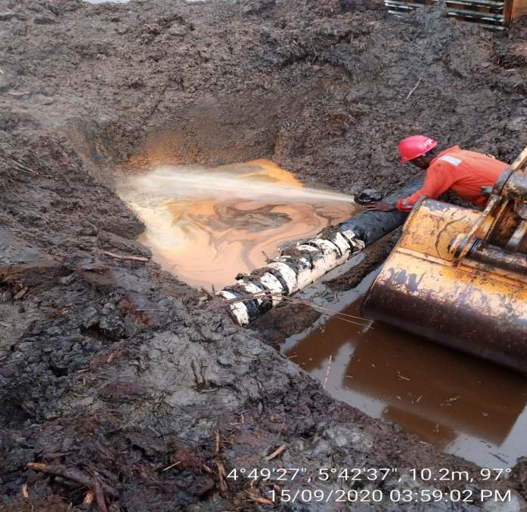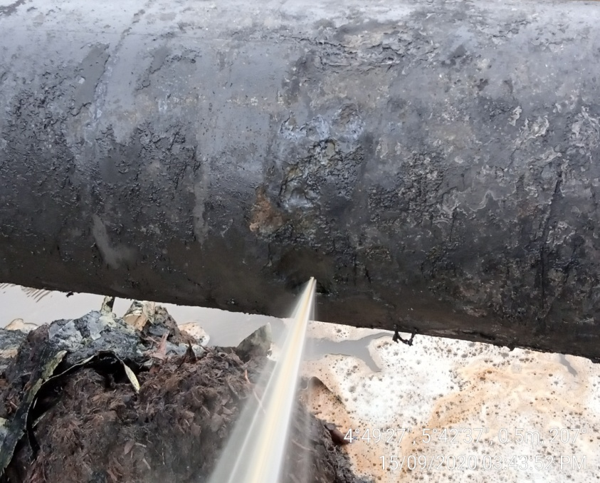
UNWRAPPING THE PIPELINE FOR SPILLED POINT SPILL POINT (Corrosion)
ASSESSMENT BY THE REPAIR PERSONNEL

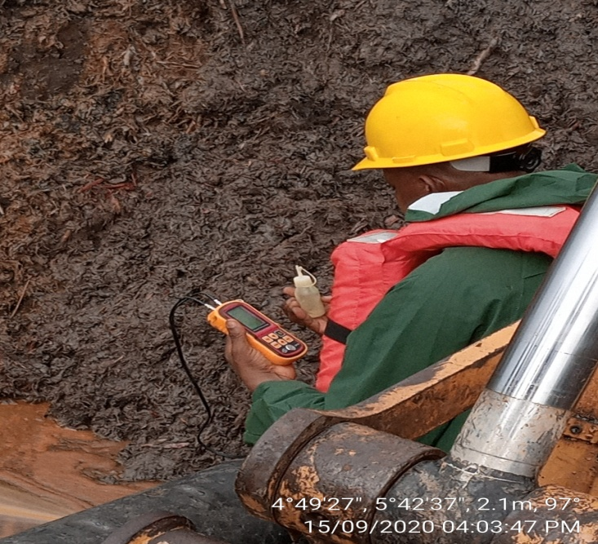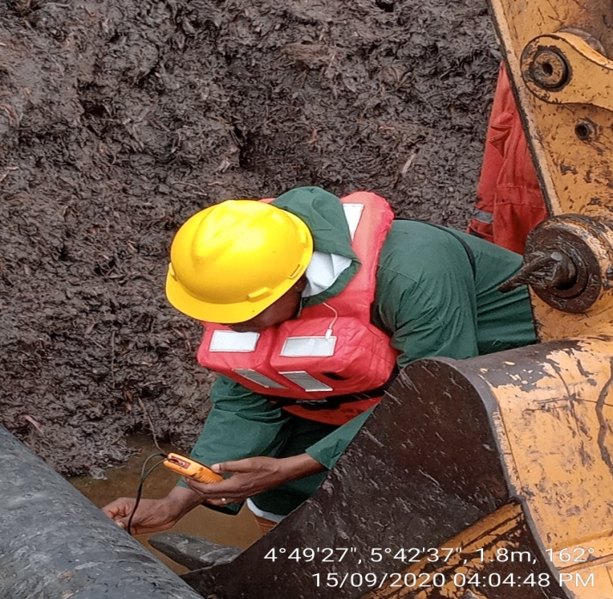
UTM RESULT
AROUND LEAK
i. 3.5mm
ii. 3.9mm
iii. 3.5mm
iv. 3.9mm
PIPELINE SCHEDULE
MAX: 12.70mm
MIN: 9.70mm

UTM (Uitrasonic thickness measurement) READING WITHIN AND AROUND THE LEAK POINT
MACHINE USING UTM BY NAOC PERSONNEL

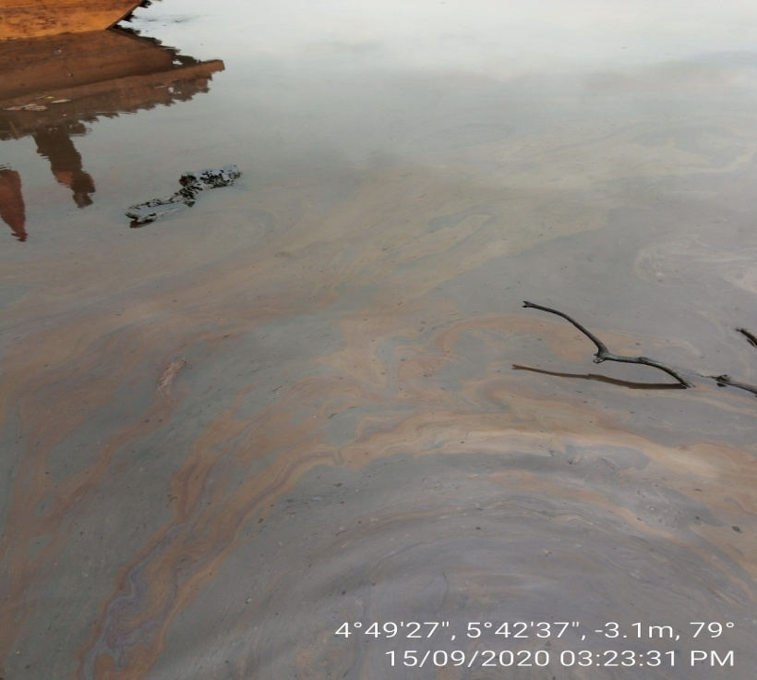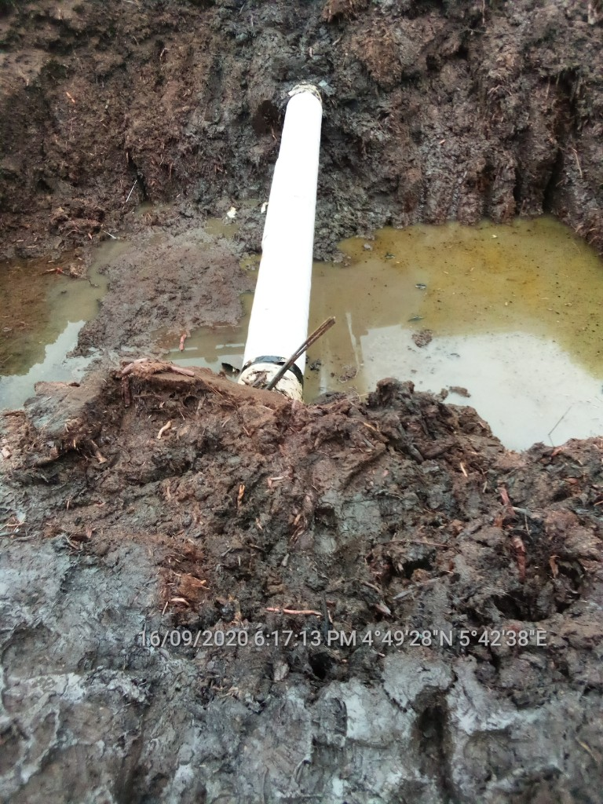
IMPACTED AREA REPAIR POINT

